I bought MW3 unit (three nodes) and want to add them into existing MW3 mesh network.

Step 1: Use mobile phone to connect MW3 WiFi network, open App, tap “Setting” > “Add nova”.

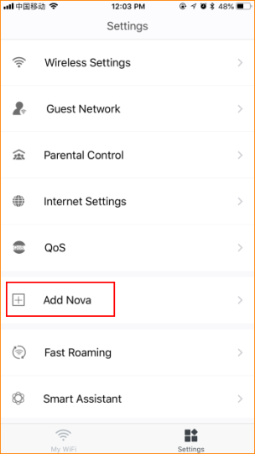

Step 2: Place the nova in an open area and keep it within two rooms (10 meters) away from existing nodes.

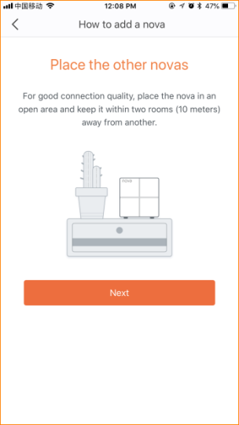

Step 3: Power on it.

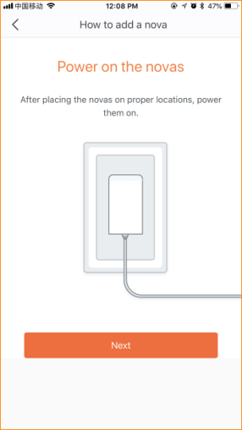

Step 4: Scan QR code or enter SN code at the bottom of the node after startup completes (LED blinks green)

Step 5: Wait for 30-40 seconds, it will show “Added”.
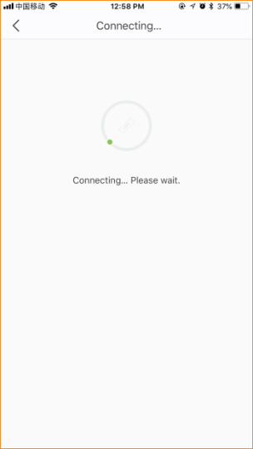
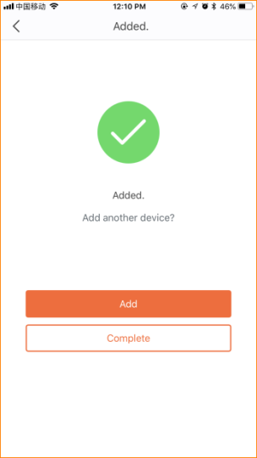

Step 6: Please add another two nodes by taping “Add” and following instruction.

Note:

If failed to add, please do as follows:
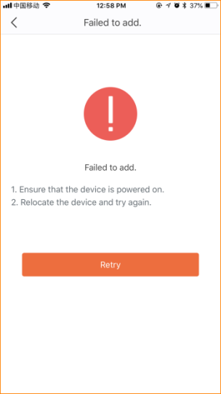

1. Ensure startup completes.
2. Ensure the node is placed within WiFi coverage of existing network.
3. Ensure you scan complete QR code.
4. You can enter SN code manually if the QR code is damaged.

